Unit 7 – Lesson 5. How do we solve the dishonest casino problems

Aim: What is Hidden Markov Model?

Objectives: After the lesson, students should be able to:
- Obtain understanding of Hidden Markov property and HMM
- Explain Hidden Markov chain using examples

References:
- CMU, Machine Learning

CLASS PROCEDURE:
Do Now: Recall yesterday we introduced the HMM and the dishonest casino problems. How did you and your partner solve the problems?
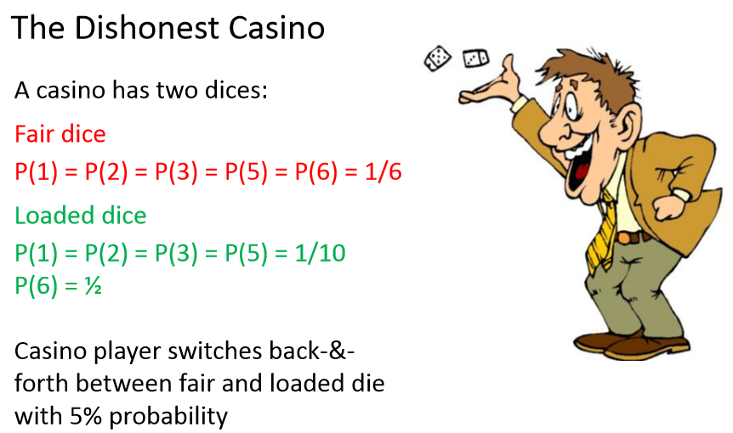
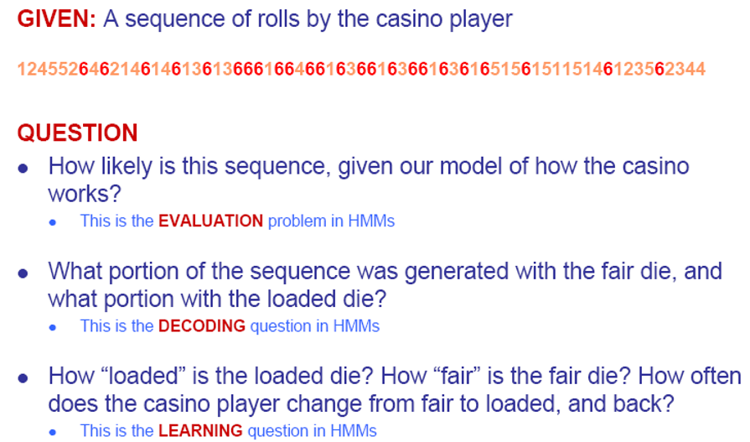

Class Discussion / Presentation:
- What is the Baye’s rule and how do we prove it?

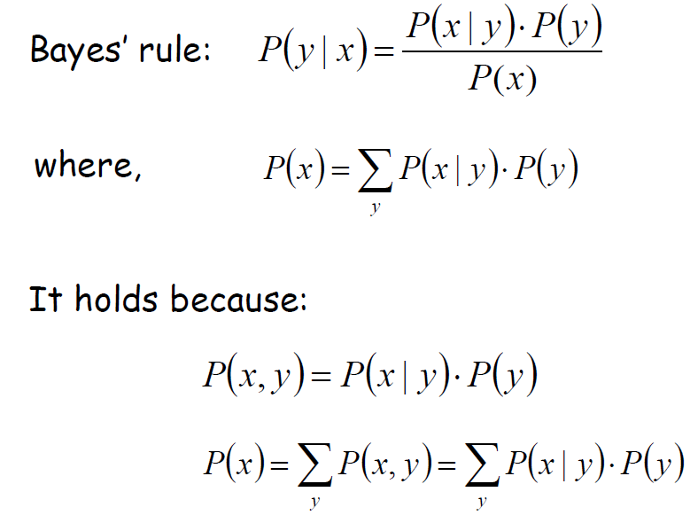
- Based upon the Bayes rule, the probability for getting three sixes:
  - P( 3 sixes | loaded dice) = 0.5 * 0.5 * 0.5
  - P (loaded dice) = 0.05 [Given: 5% chance for switching dices]
  - P(3 sixes) = P(3 sixes | Loaded Dice) P (Loaded Dice) + P(3 sixes | Fair Dice) P (Fair Dice)

As per the Bayes rule:

